

From: JM Date: 2014-01-14

To: KSL450

LCF & TCF tables (from KSL450 version 813)

The existence of the file THCorrini.txt (in the KSL450 folder) activates the use of LCF & TCF tables.

THCorrini.txt sample:

1,1 # Tank number, TLCF table Number in TCFXXXX.dat and LCFXXXX.dat
2,2 # Tank number, TLCF table Number in TCFXXXX.dat and LCFXXXX.dat

If no matching table is found for the corresponding tank number,
the AP-LCF (APL) & CL-TCF (CLT) values from the confXXXX.ksl file are used.

TCFXXXX.dat sample:

# TCF table for order: XXXX
# Number of tables in this file: 1
1
# Number of points in this table: 1
1
# Level, CL-TCF
0,0

LCFXXXX.dat sample:

# LCF table for order: XXXX
# Number of tables in this file: 2
2
# Number of points in this table: 4
4
# Level, AP-LCF
0,198
10,199
20,200
30,197
# Number of points in this table: 4
4
# Level, AP-LCF
0,123
10,122
20,121
30,122

From: JM Date: 2014-01-14

To: KSL450

When table values are used, the text (table) is added to the corresponding labels
in the Compartment section of the Calibration picture:

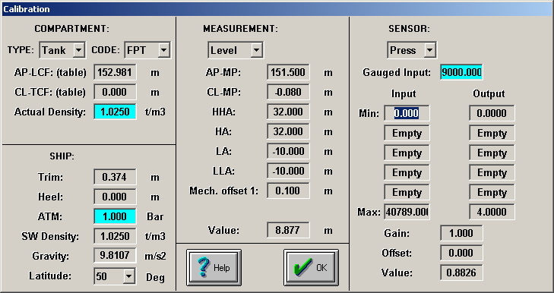

Fragment from LCFtable:

8.8,153.006
8.9,152.973

